Ideation Phase
Empathize & Discover

Date | 31 January 2026
Team ID | LTVIP2026TMIDS24962
Project Name | Empowering India: analysing the evolution of union budget allocations for sustainable growth
Maximum Marks | 4 Marks

Empathy Map Canvas:
An empathy map is a simple, easy-to-digest visual that captures knowledge about a user’s behaviours and attitudes.

It is a useful tool to helps teams better understand their users.
Creating an effective solution requires understanding the true problem and the person who is experiencing it. The exercise of creating the map helps participants consider things from the user’s perspective along with his or her goals and challenges.
Example:
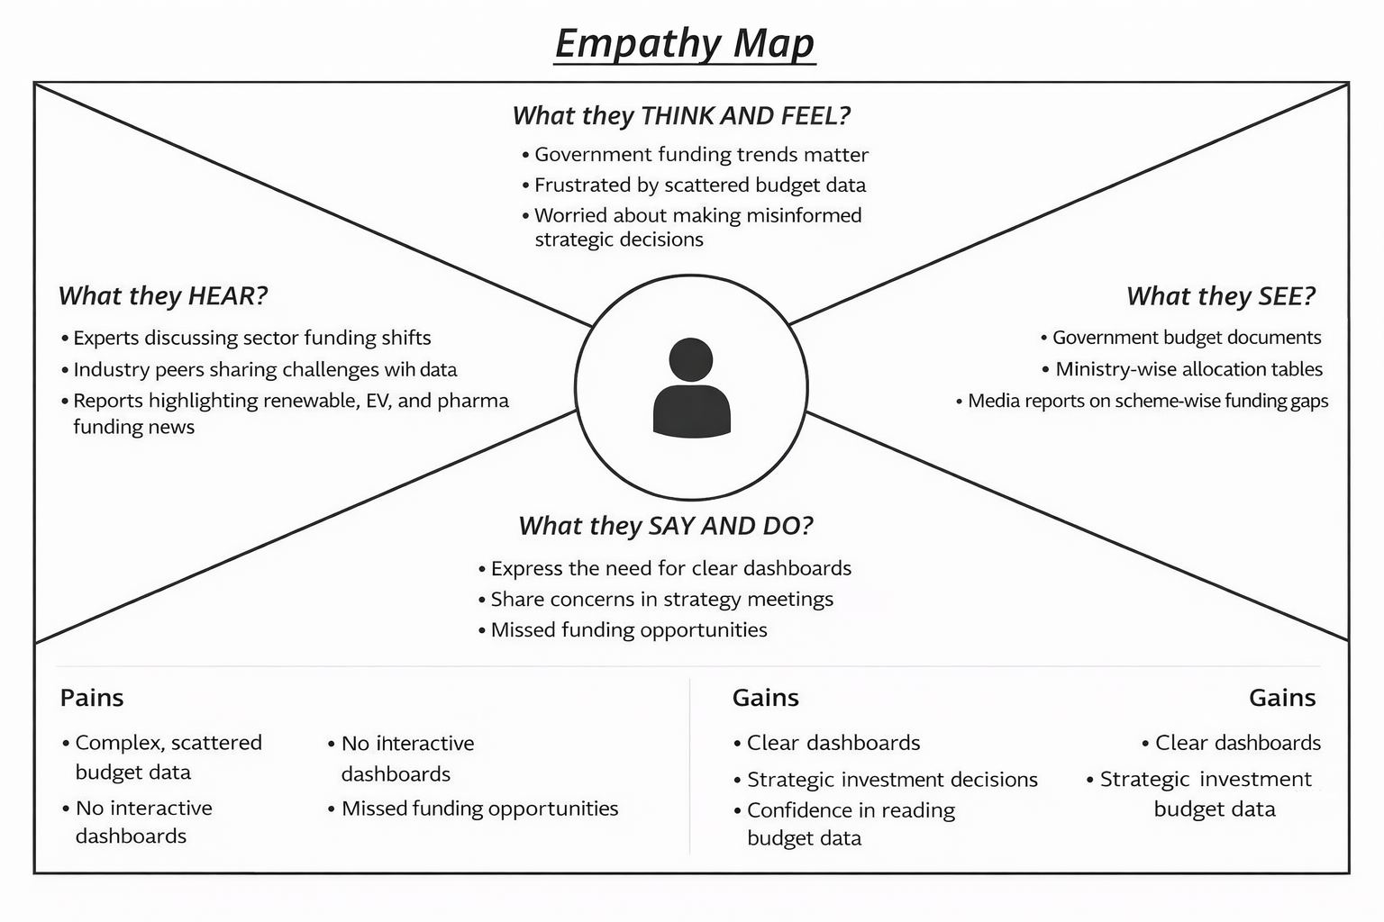

Reference: https://www.mural.co/templates/empathy-map-canvas

Example: Empathy Map for Union Budget Data Analysis Project
